Assignment 1

Sarpreet Singh Buttar(sb223ce), and Songho Lee(sl222xk)

# Task 1 (MovieDB)

There are several assumptions we made while we interpreted the tasks.

## Assumptions of the diagram

The line with arrow ‘➝’ represents zero or one entity.

The line without arrow represents zero or more.

## Assumptions of the statements

We interpreted ‘Some’ as true if there is a case which our model allows.

Also, we assumed “most” means there are more than half cases are true.

For ‘every’ to be fulfilled, there should not be any counter case.

## Cases

1. False. Since the ’performs-in’ relation is having zero or many multiplicity, there can be an actor which has not performed in any movie.
2. True. Since the multiplicity does not have any specific limitation (many-to-many), there can be a case.
3. True. The relationship that actor leads role has multiplicity that does not limit the number. Thus, there can be a case.
4. False. It can only have either zero or one.
5. False. There can be a case where the actor is not the director.
6. False. There can be a case where producer is an actor.
7. False. There can be a case where a producer can be an actor, who performs in multiple movies.
8. True. There can be a case because there is no limit in numbers
9. True. There can be a case that a producer who is an actor is also a director.
10. Maybe. Our model allows the given case; however, it cannot be proved based on the data-model diagram.
11. True. There can be a case, as movies have many-to-one relation to directors and many-to-many relation with the producers.
12. True, it does not violate the model as actors can have lead roles in many movies and also be the director and one of producers at the same time.
13. False, if a director is an actor, it is possible that he can have the both roles.

# Task 2 (Births)

The following E/R diagram is created which fulfils the requirements one, two and three.

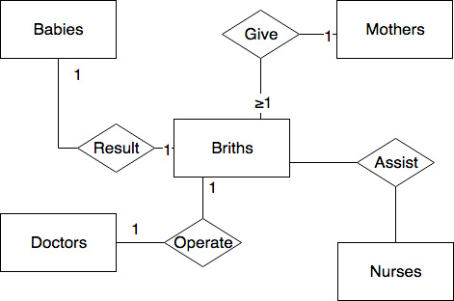  
We applied one-to-one relation, between babies <-> births and births <-> doctors to prove the uniqueness. We also applied one to one on both mothers and births, since if a mother has more than one birth, the mother is not unique anymore.

## Design flaws of the model

In the first case, the relation that a birth should not include more than one baby makes twins are not allowed as every birth is of unique baby.

In the second case, a doctor can only operate one birth to be unique; One doctor cannot operate more than one birth.

## New model

For birth to include more than one baby, we changed multiplicity of the births-results-babies relation to be greater or equal to one. It results in the following figure.

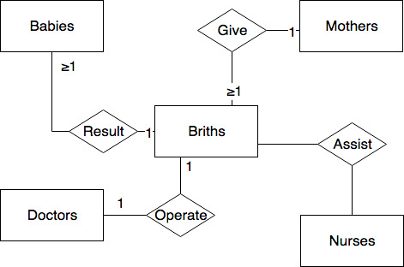

We represent that every baby has a unique mother as the multiple babies which resulted in a birth has a relation to a single mother.

# Task 3 (registrar’s office)

We constructed E/R model of the given scenario.

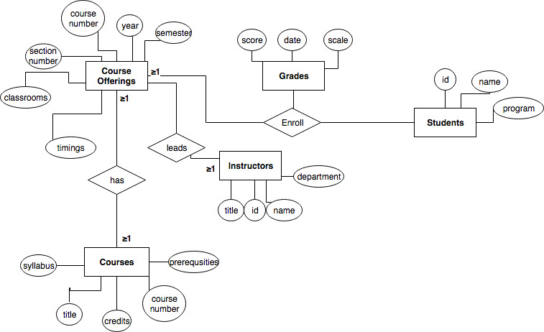

Students are enrolled in one or more course offerings of a course, and this enrolment has a grade entity. Students need to enrol at least one course offering, because according to our judgement, a person is not a student if she is not enrolled in a single course offering. A course needs at least one instructor, and a course can have at least one course offering or more so that students can enrol the course.

We removed one attribute ‘instructor’ from the course offerings; we replaced with the complete ‘instructor’ entity set, to allow having more than one instructors on a course offering.

# Task 4 (Classroom scheduling)

We created the E/R model of the exam scheduling database of a university.

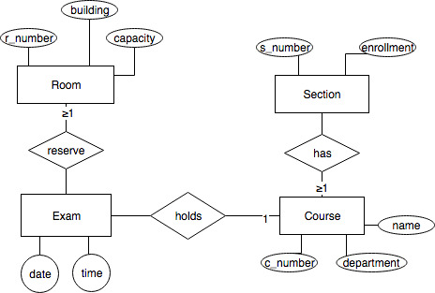

## Assumptions we made

We assumed that a course can have zero or more sections but a section needs at least one course as it is a weak entity. A course can have zero or many exams, while an exam much represents a course if the exam exists. Exam need at least one room to be held, but room can be left empty if it is not booked.

## Attributes

Additionally, we added a date attribute on the exam entity as we see it as necessary.

## Application characteristics

If we would like to represent the attributes of course, section and room, it would influence our decision to include these as additional entity sets rather than having them as attributes of a single entity.